**Practical-8**

**Aim: Write an Assembly Language Program to find the sum of 5 numbers using loop.**

**Source Code :**

start: nop

MVI B, 05H

LXI H, 0001H

LOOP: MOV C, M

ADD C

INX H

DCR B

JNZ LOOP

STA 0006H

hlt

## Output :

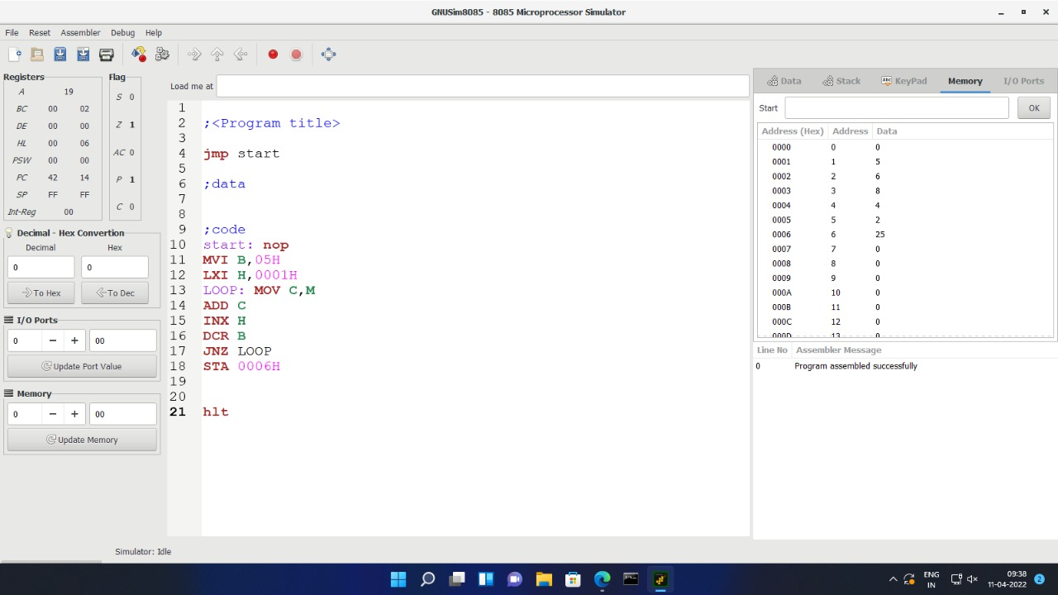

**Practical-9**

**Aim: Write an Assembly Language Program to find smallest Number From an array.**

**Source Code :**

LXI h,000h

MOV b,m MOV s,m MVId,0ah

LOOP: MOV a,mCMPb

JC min MOV b,a Min: CMP a JNC skip MOV c,a Skip: INX h DCR d

JNZ LOOP LXI h,000ah MOV m,b INX h

MOV m,a

## Output :

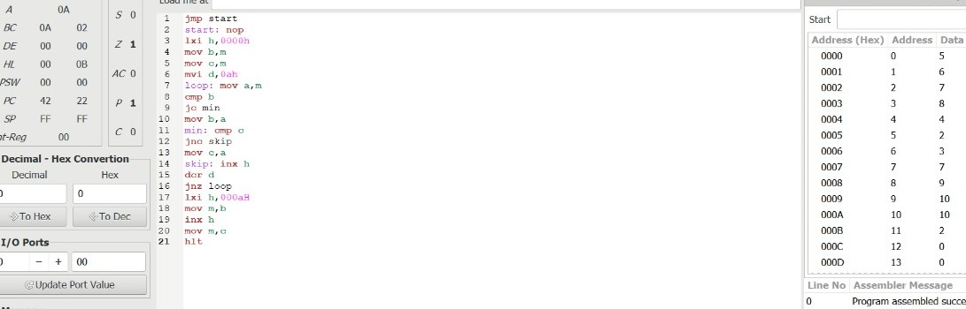

**Practical-10**

**Aim: Write an Assembly Language Program to arrange given numbers in ascending order.**

**Source Code :**

Jump start

Start: LXI H,0001h MVI D,00 MVI C,04

Check: MOV A,MTNX H CMPM

JC NXTBYT MOV B,M MOV M,A DCX H MOV M,B INX H

MVI D,01 NXTBYT: DCR C

JNZ Check MOVA,D RRC

JC start

## Output :

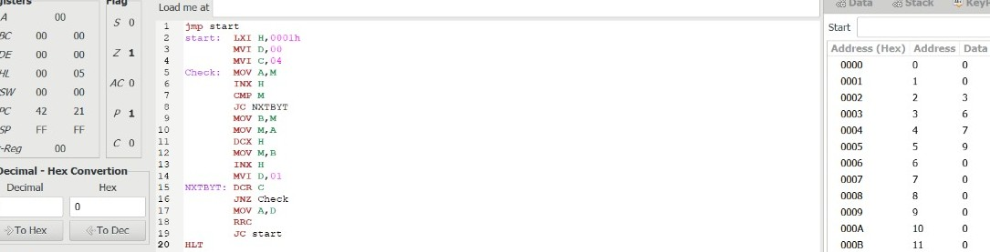

**Practical-11**

**Aim: Write an Assembly Language Program to find the factorial of a given number.**

**Source Code :**lxi sp,27ffh ldavar2

opi 02h jc last

mvi d,00h mov e,adcr a

mov c,a call facto xchgshld var jmpend

last: lxi h,0001h end: shld var

hlt

facto: lxi h,0001h mov b,c

back: dad d dcrb

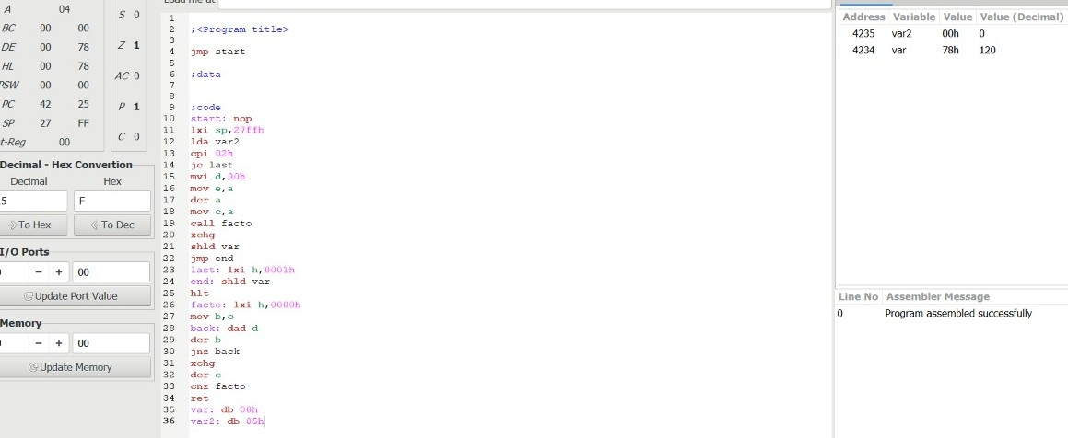jnzback xchgdcrc

cnz facto ret

var: db 00h var2: db 05h **Output :**